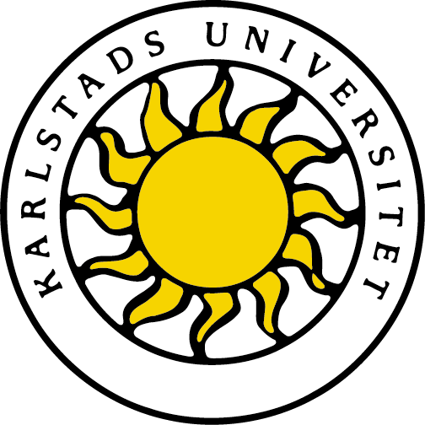
Karlstads universitet 651 88 Karlstad
Tfn 054-700 10 00 Fax 054-700 14 60
Information@kau.se www.kau.se

Oticon – culture metaphor
Seminar 3

Industrial Marketing and Organization:
Competence and leadership

Prepared by:
Antoine Bernard (900201-T295)
Stéphanie Bertin (880921-T223)
Virginie Millet (890901-T168)
Fadjer Muhi (850911-4685)
Date/Term: 06-02-12
Supervisor: Markus Fellesson
Examiner: Markus Fellesson

Introduction
This report relates the organizational structure of Oticon Company; it examines how the cultural metaphor matches to this company. Our assignment starts first with this introduction including a brief description of Oticon Company. Then, a theory part introduces the metaphor of culture from the perspectives of values, symbols and actions. In the last part, we will rely on the theory to analyze the case according to the culture metaphor and then draw some conclusions.
In 1904, Hans Demant created Oticon Company; a Danish family business specialized in hearing aid devices. Seventy years later, thanks to the development and the production of their flagship products the BTE (Between The Ear) devices, they became the world leader of their market. While their competitors explored new technologies such as ITE (In The Ears) hearing aids, Oticon stayed focused and confident in standard BTE devices; they weren’t aware of the importance of innovation. So that, after the 1987’s financial crisis, they lost about fifty percent of their cash flow within a year. This situation urged them to react. The company decided to hire Lars Kolind as a new CEO. He came up with a new ambitious organization system, and with many new fresh ideas to improve the company`s future. It took only a few years for Lars Kolind to turn Oticon into a profitable, modern, and successful company.
Theory
Culture could be defined as a common knowledge shared by a group of individuals linked by their history and/or their social environment. Anthropologists defined the different cultures by observing the behalf of populations and highlighting some common habits. There are different levels of culture from the national one to the individual one, but no matter the number of people involved in it, this common background is necessary to behave against each other and live together in the organization they belong to. A lack of culture could lead to chaos. As the culture is part from our personality and identity, it is very difficult to go against the culture of someone or to change it.
Culture is conveyed through values and symbols and lead to actions. Values express the way things should be, they gather the beliefs you have to trust in and to respect if you want take part from an organization. They can be illustrated with many symbols which are signs that stand for something bigger than themself with a strong meaning. Symbols may be of different nature, they could be material (building, clothes, logos...), actions (ceremony, corporate parties…) or verbal (stories, songs…). Both symbols and values lead the person who believes in it to behave according to them and respect them.
Analysis
When Kolind was hired, he had to face the history and the background of Oticon, especially the strict hierarchy and strong traditional relationship among employees. The managers explained him that it is a family business with a strong culture frozen with no developed ideas for 60 years with some professional standards, norms and privileges. They were very confident and satisfied about their position in the market, so they didn’t question their policy instead they said;
“We want to preserve the Oticon spirit and our tradition of success” Oticon (A) pp.6
So the values were old fashioned like traditional, hierarchy organizational structure, expertise, and stability.
Moreover, Kolind had to fight against a strong national culture. Due to Kolind former work in the USA, he was used to a very flexible working environment. That was not the case in Denmark where people don’t adapt easily to changes; instead they just follow the rules. For example, they were reluctant to the change in working hours; that was obvious to Kolind when they complained about the late meeting. Besides, the Danish people don’t like uncertainty avoidance and prefer to work collectively. Kolind was against this believes, he wanted to implement an individual work with no longer job security.
History and national culture explain why the new plan for changing the company`s structure met a lot of resistance when Lars Kolind presented it first. However, the vital role played by Kolind greatly formed the new culture and forced different values on Oticon.
After the organization upheaval and the setting up of the new culture in Oticon, eight new commandments now lead the organization: modernity, communication, equality, freedom, innovation, involvement, responsibility and self-fulfilment. In the new organization many symbols are used to spread these values.
Firstly, the offices were moved in a brand new building. From an outside point of view, this building is the first obvious action which shows that Oticon is making a fresh start and moving to modernity, while forgiving the old traditional company: this is the symbol of the beginning of a new chapter. The design in this new building is also an important revolution! Indeed, now there are no longer separated offices, such as “boxes”, but everybody works in an open-space on a movable desk, with a new computer, so that people can communicate easier. The office’s central spiral staircase was also designed to be wider than normal to provide informal space for people to talk while others passed by. Moreover, each floor had a coffee bar, all of this surely promote oral communication and help people become closer each other. Related to these values, Kolind settled the paperless company: the target of this action is to ease communication and decision making. On top of that, Kolind speaks about Spaghetti organization, to describe the fact that everybody is equal-there is no longer managers- and keeps in touch with the others. So, with these materials and verbal symbols, the new CEO aims at showing to all employees that they are equal and that communication is now the key of the success!
Equality and communication, associated with the fourth value which is freedom, lead to an important action in the company which is skunk work: whoever you are, whatever the studies you did or the job you were hired for, you can get an idea or work on a colleague’s idea, you are no longer limited to do one task at a time! Team work is now promoted, you find an idea by communicating with other people from other departments and then you work freely in a multi-functional group where everybody is equal. This new way of working is a real achievement of the tree values: equality, communication and freedom!
After analysing the competitor weaknesses, Kolind noticed that the only way to be back on the market is to be innovative. So another organization’s value is to promote creativity, and to encourage the use of new technology. The perfect symbol must be the launch of the so-called MultiFocus product, which was underway since 1979, and almost abandoned. Finally, it appeared that the idea was innovative and so all the organization worked on it. It was the first great success of the new organization. Moreover, Kolind thank that new technologies could really help the company to be more innovative. That's why a computer was offered to any employee. This action is also another symbol of the company willingness to be innovative, and it surely helped everyone to be much more comfortable with computer sciences and all its possibilities.
Kolind also promoted a new revolutionary way of involving people. Contrary to the traditional way, the link between the company and employees is stronger. The fact that everybody can buy company’s shares well symbolizes this involvement. And as there is no longer a clear hierarchy, people have to be responsible. For instance, people who initiate an idea typically become the project group. And there is a project manager from this team who “run the show” and a project owner from the management team who just supports the project – do not manage it. Then each project team is quite free and responsible for its idea.
All those new ideas help to fulfil very well the two last levels of the Maslow's hierarchy of needs. Actually, in this type of organization, there is much more self-esteem and self-actualization because when somebody get an idea, he can make it grow with the help of all other employees. This project work form is the real action that supports self-fulfilment.
Conclusion
The culture metaphor is the combination of symbols, values, and norms. Kolind managed to go around the Danish culture and the traditional former Oticon’s culture by creating both material and verbal symbols for Oticon in order to reflect the new values he wanted to set up. When organizational symbols are perceived by employees, they trigger the spreading of internal values and norms. They are a bridge from feeling to thoughts, while thoughts will then lead actions in accordance with the organization culture.

References
- Morgan G. Images of Organization. Thousand Oaks, California. Sage Publications; 2006.
- John Kao Oticon (A) case study, Harvard 2001.

